COMSATS UNIVERSITY, ISLAMABAD.



Submitted by: | Minahil Javed (FA24-BBD-095)
Submitted to: | Sir Muhammad Ahmad
Program & Course title: | Business Data Analytics (5-C)  Machine Learning
Date of submission: | October 30, 2026.

Introduction
This app predicts an employee's monthly salary and their risk of leaving, and lets the user pick which of five algorithms makes the prediction.
- Salary (regression): predict MonthlyIncome from 16 HR features.
- Attrition (classification): predict whether an employee will leave (Attrition = Yes or No).
- Model comparison: Linear/Logistic Regression as the baseline, then Decision Tree, Naive Bayes, Random Forest and SVM.
- Deployment: a FastAPI backend and an HTML frontend with a Select Model menu.

Dataset
The IBM HR Employee Attrition dataset has 1,470 employees and 35 columns, with no missing values. Only 237 employees (16.1%) left, so the attrition classes are imbalanced.
- Attrition: 1,233 stayed (83.9%), 237 left (16.1%).
- MonthlyIncome: mean 6,503 USD, median 4,919 USD, range 1,009 to 19,999 USD.
- Departments: Research & Development 961, Sales 446, Human Resources 63.
- Overtime: 30.5% of employees who work overtime left, against 10.4% of those who do not.
Sixteen features are used as inputs: Age, DailyRate, Department, DistanceFromHome, Education, EnvironmentSatisfaction, JobLevel, JobSatisfaction, MonthlyRate, NumCompaniesWorked, OverTime, StockOptionLevel, TotalWorkingYears, TrainingTimesLastYear, WorkLifeBalance and YearsAtCompany.
Source: data/raw/HR-Employee-Attrition.csv.

Methodology
Department and OverTime were label-encoded, the data was split 80/20 with random_state 42, and every model was scored on the same held-out 20% (294 employees).
Model | Salary (regression) | Attrition (classification)
Linear / Logistic Regression | Linear Regression | Logistic Regression, max_iter 1000
Decision Tree | max_depth 6 | max_depth 5
Naive Bayes | not applicable | Gaussian Naive Bayes
Random Forest | 200 trees | 200 trees
SVM | SVR, linear kernel, C 10000, scaled | SVC, RBF kernel, C 1, scaled
Naive Bayes only does classification, so it has no salary model. SVM is distance-based, so it runs in a pipeline with StandardScaler. Salary is scored with R² and attrition with accuracy.

Results
SVM scored best on attrition (88.8% accuracy) and Random Forest best on salary (R² 0.918), but the gaps between models are small.
Model | Salary R² | Attrition accuracy
Linear / Logistic Regression | 0.895 | 87.8%
Decision Tree | 0.910 | 82.7%
Naive Bayes | not applicable | 88.4%
Random Forest | 0.918 | 87.4%
SVM | 0.896 | 88.8%
Test set of 294 employees, random_state 42.
- Salary: all four models explain about 89% to 92% of the variance, so any of them is usable. Random Forest and Decision Tree beat the linear baseline by 2.3 and 1.4 points of R².
- Attrition: predicting that everyone stays would already be right about 84% of the time. Decision Tree (82.7%) falls below that, and the other four sit only 3.5 to 4.9 points above it.
- Caveat: accuracy does not show how many of the employees who actually leave are caught. Precision and recall were not measured.

System design
One FastAPI service loads all nine trained models at startup, and the browser picks one per request with the model query parameter.
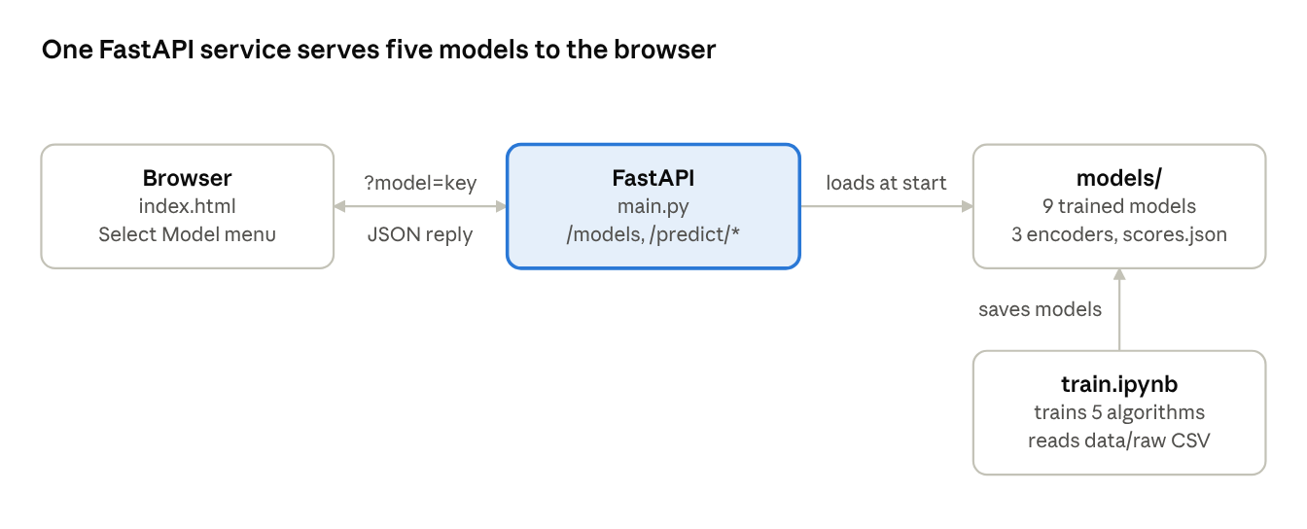
system architecture · 4 components
Endpoint | Purpose
GET /models | Model names with their test scores
POST /predict/regression?model=key | Predicted monthly income
POST /predict/classification?model=key | Attrition risk
Model keys are linear, decision_tree, naive_bayes, random_forest and svm. Choosing naive_bayes for salary returns a 400 error, and the frontend disables the Salary button in that case.

Conclusion and limitations
The app meets its goal: five models are trained, compared and switchable from the browser, with Random Forest leading on salary and SVM on attrition.
Limitations
- The form asks for only 5 inputs and sends fixed defaults for the other 11 (for example DailyRate 800 and JobSatisfaction 3), so predictions change only with those 5 fields.
- Attrition is imbalanced (16.1% leavers) and only accuracy was measured.
- Models use fixed hyperparameters, with no cross-validation or tuning.
- Logistic Regression ran on unscaled features and raised a convergence warning during training.
Future work
- Add precision, recall, F1 and ROC-AUC, and use class weights for the minority class.
- Tune hyperparameters with cross-validation.
- Expose all 16 inputs in the form.

